***Assignment 4***

Q-1:

import java.util.Scanner;

class Pizza {

final double TOPPING_COST = 1.75, SMALL_COST = 8.0, MED_COST = 10.0, LARGE_COST = 12.0;

final int MAX_TOPPINGS = 10,SMALL = 1,MEDIUM = 2,LARGE = 3;

int size = 0, toppings = 0;

public Pizza() {

}

public Pizza(int size, int toppings) {

this.size = size;

this.toppings = toppings;

}

public int getSize() {

return size;

}

public int getToppings() {

return toppings;

}

public void setSize(int size) {

if (size > 0 && size <= 3) {

this.size = size;

} else {

System.out.println("Entered Size doesn't match with the stored size");

System.exit(0);

}

}

public void setToppings(int toppings) {

if (toppings>= 1 && toppings <= 10) {

this.toppings = toppings;

} else {

System.out.println("Invalid Entry! Number should be between 1 and 10.");

System.exit(0);

}

}

public double calcPrice() {

double Price=0.0;

int size = getSize();

int toppings = getToppings();

if (size == 1) {

Price = SMALL_COST;

} else if (size == 2) {

Price = MED_COST;

} else if (size == 3) {

Price = LARGE_COST;

}

Price+= TOPPING_COST*getToppings();

return Price;

}

public String toString() {

String Display=null;

if (size == 1) {

Display = "Small Pizza";

}

else if (size == 2) {

Display = "Medium Pizza";

}

else if (size == 3) {

Display = "Large Pizza";

}

Display = Display + "\n" + this.toppings + " Toppings" + "\nTotal Bill: $" + calcPrice();

return Display;

}

public static class PizzaOrder {

public static void main(String[] args) {

Scanner input = new Scanner(System.in);

Pizza objPizza = new Pizza();

System.out.println("Enter the size of Pizza");

System.out.println("Choose Number:\n for Small Pizza= 1 \n Medium Pizza= 2 \n Large Pizza= 3");

int size = input.nextInt();

objPizza.setSize(size);

System.out.println("Enter Number of Toppings(Number should be between 1 and 10): ");

int toppings = input.nextInt();

objPizza.setToppings(toppings);

System.out.println(objPizza.toString());

}

}

}

Output:

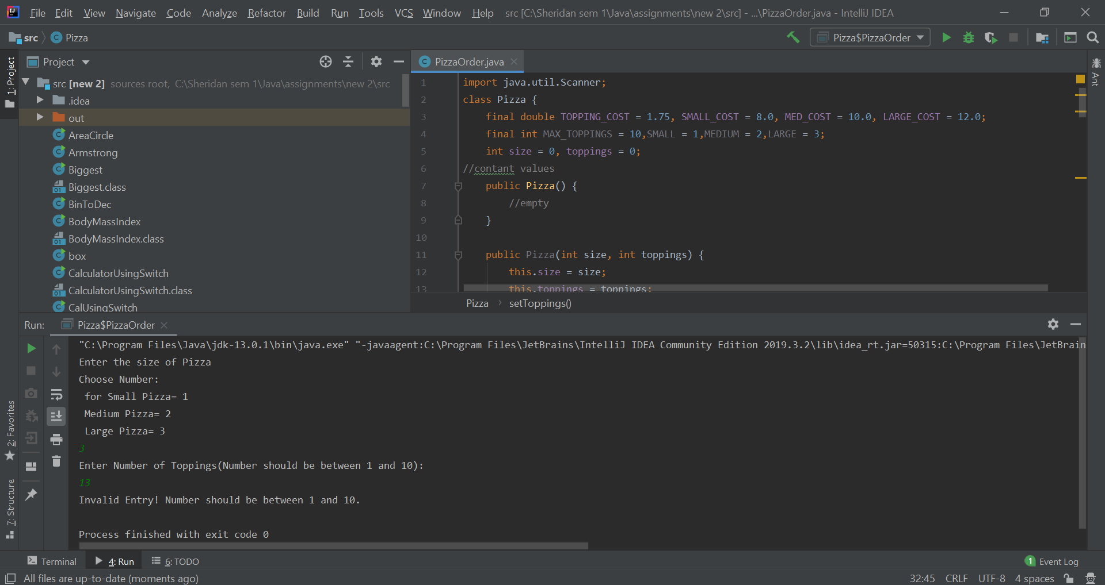

**Q-2:**

**UML Diagram Student:**

|  |
| --- |
| **Student** |
| **+StudentName: String**  **-idNum: int**  **-SemNo:int**  **-noCourses:int** |
| **+Student()**  **+Student(studentName: String, id: int)**  **+getStudentName(): String**  **+getIdNum(): int**  **+setStudentName(studentName: String):void**  **+setIdNum(idNum: int): void**  **+getSemNo(): int**  **+setSemNo(semNo: int): void**  **+getNoCourses():int**  **+setNoCourses(noCourses: int):void**  **+toString(): String** |